[](http://www.bing.com/images/search?q=clip+art+new+orleans&view=detail&id=0D3880414582BD4E12DF0B39D1961788D275BAE3)

**PeriOperative Potpourri**

**New Orleans - Chapter 1902**

November 2021

**2021 – 2022 Officers**

**President**

Mary Anne S. Toledano, BS, BSN, RN, CNOR [maryanne.toledano@ochsner.org](mailto:maryanne.toledano@ochsner.org)

**President-elect**

Roxanne McNally, BSN, RN

[**rleblanc4@gmail.com**](mailto:rleblanc4@gmail.com)

**Vice President**

Sharon Guardina, BSN, RN, CNOR

[sguardina@att.](mailto:sguardina@att.)net

**Secretary**

Rochelle Cazaubon, BSN, RN, CNOR

[rochellecazaubon@gmail.com](mailto:rochellecazaubon@gmail.com)

**Treasurer**

Bobbi Carew, RN

[Roberta.carew@ochsner.org](mailto:Roberta.carew@ochsner.org)

**Board of Directors:**

**(2020-2022)**

Melissa Guidry, RN, MPH, CNOR [guidrymelissa@yahoo.com](mailto:guidrymelissa@yahoo.com)

Elaine Stock, RN, BSN, BA, CNOR

[elayna98@icloud.com](mailto:elayna98@icloud.com)

Nathalie Walker, MBA, RN, CNOR

[Gw\_nat@bellsouth.net](mailto:Gw_nat@bellsouth.net)

**(2021-2023)**

Nora Lambert, BSN, RN, CNOR

[DIXIELANDCATZ@HOTMAIL.COM](mailto:DIXIELANDCATZ@HOTMAIL.COM)

Sheila Ostrow, RN, CNOR, CRNFA [Sheila.ostrow@gmail.com](file:///\\ochsner.org\users\m\1025256\AORN%20Newsletter\4Oct-Dec\2021\Sheila.ostrow@gmail.com)

**Nominating & Leadership Development**

Judy Montello, BSHCA, RN, CNOR [Judy.Montello@lcmchealth.org](mailto:Judy.Montello@lcmchealth.org)

Kim Conway, MHA,BSN,RN-BC

[kimcon@bellsouth.net](mailto:kimcon@bellsouth.net)

Kristi Guillot, RN

[Kristi.guillot@lcmchealth.org](mailto:Kristi.guillot@lcmchealth.org)

**LA State Council Liaison:**

Sharon Guardina, BSN, RN, CNOR

[sguardina@att.net](mailto:sguardina@att.net)

**Newsletter Editor**

Mary Anne Toledano, BS, BSN, RN, CNOR [matoledano@outlook.com](mailto:matoledano@outlook.com)

**Webmaster**

Ramie K. Miller, MSN, RN, CNOR [ramiemiller@yahoo.com](mailto:ramiemiller@yahoo.com)

**President’s Message**

Louisiana was obtained by Nathalie Walker and is attached the email. Please post in your department.

We have our annual social scheduled for November 17th at Martin Wine Cellar from 5pm-7pm to celebrate Perioperative Nurses’ Week. The event is being sponsored by Melissa Guidry and Warren Roesch from StratAx and your chapter. It will be an opportunity to get to know our new members and see faces we don’t get to see often. Bring a potential member and a new OR nurse with you. There is no cap for this meeting, so plan on attending. 😊

We will have another *Painting with a Twist* party on December 15th from 4:30-7pm. There is a cute snowman that matches the one we did last year. Or we can do something different. Let me know if you want to participate and

which one you want to paint.

I hope to see all of

you on the 17th!

Stay strong,

Mary Anne

Hello Members,

I hope everyone had a fun and safe Halloween. Here are some photos from the chapter meeting on October 27th.

Rhonda Nabors, Bobbi Carew and MA Toledano.

*Level 1*

*Crash*

*Dummies*

Jennifer Foster and Roxanne McNally

It was a fun night, despite the bad weather. Aerobiotix sponsored the dinner at Superior Seafood and provided a CE credit too. The level one crash dummies won first place in the costume contest. Do you recognize the white “bunny” suits? Great costume ladies!

The business meeting that night was short due to the noise and room layout. Remember that **Perioperative Nurses’ Week is on November 14th-20th.**  The proclamation from the state of

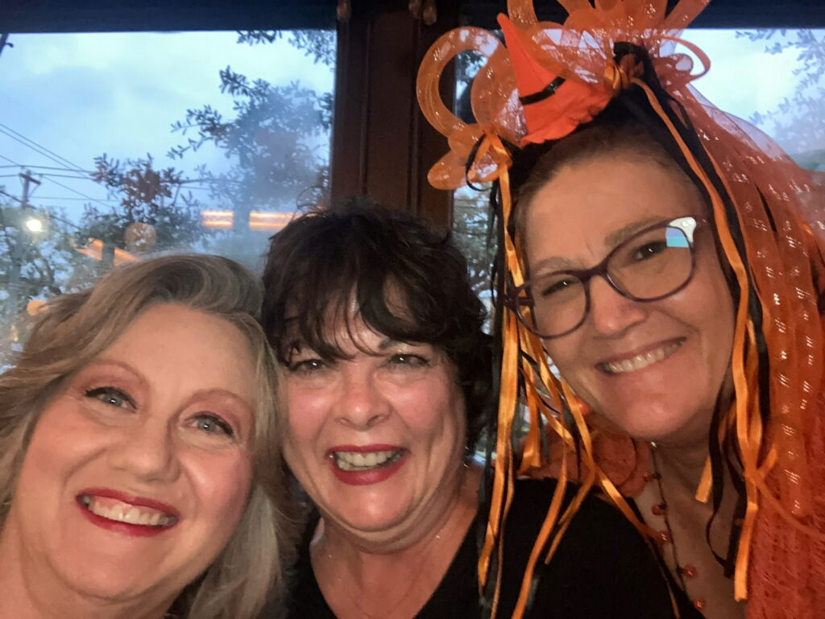

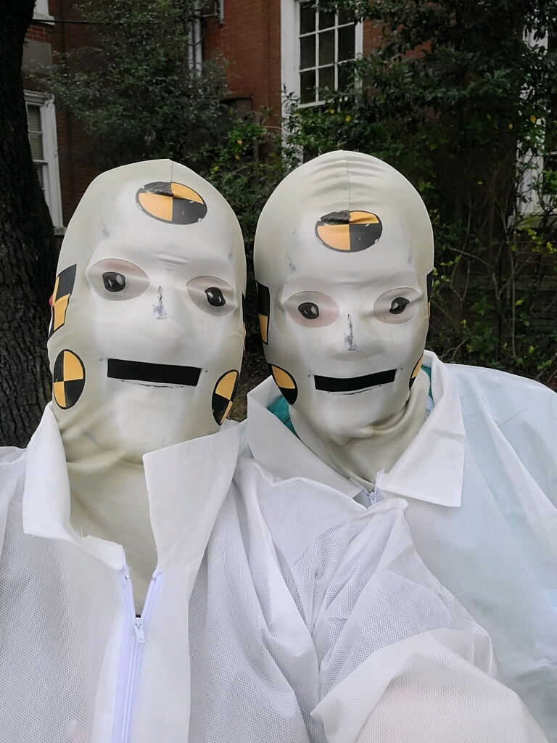

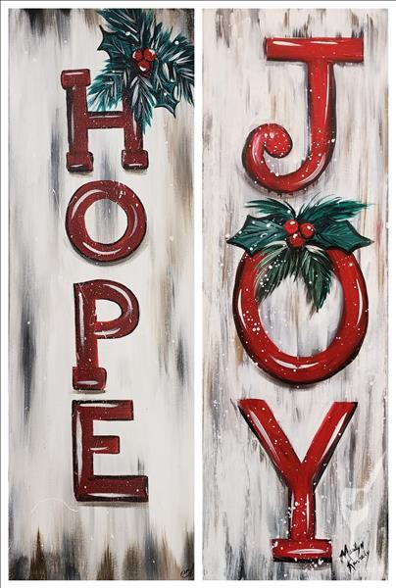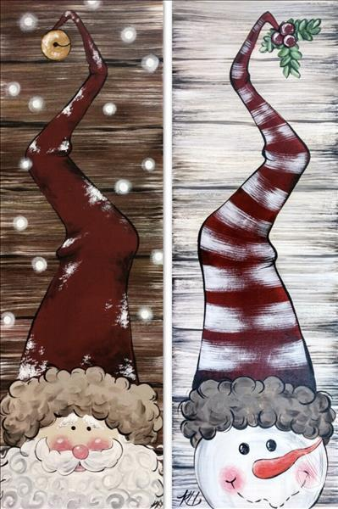

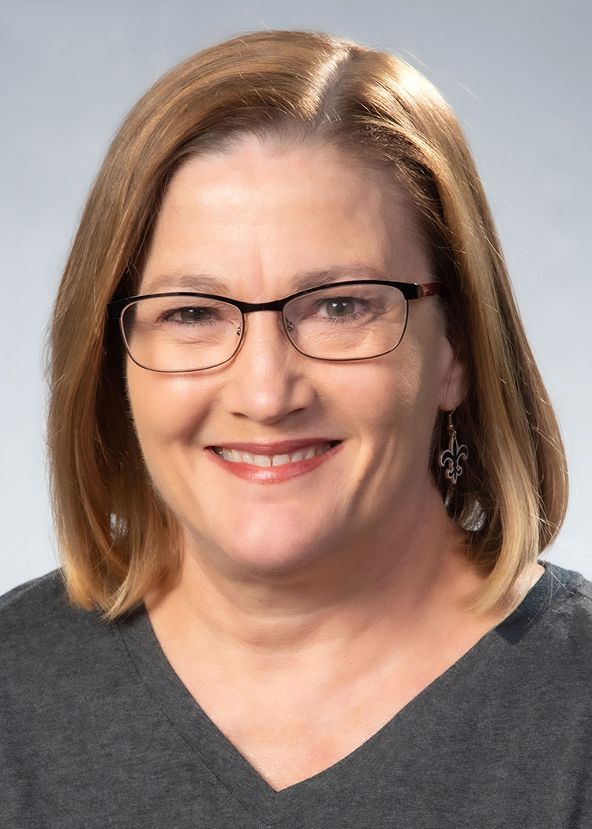

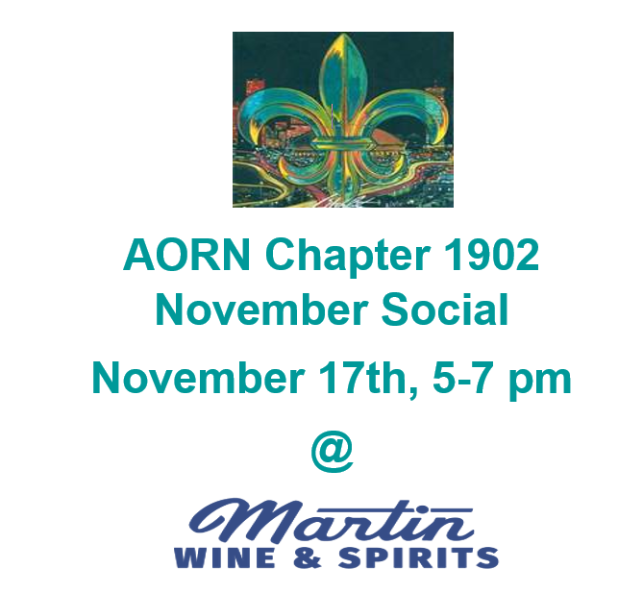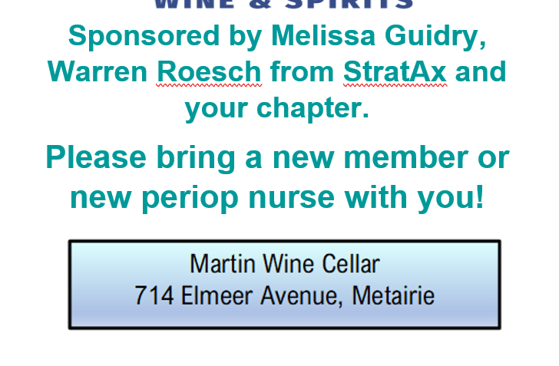

**Chapter 1902**

##### **Event Calendar**

**2021-2022**



**Nov.** **17th-** 5 pm–7 pm, Social at Martin’s Wine Cellar, sponsored by Melissa Guidry and Warren Roesch from StratAx and your chapter.

**December 15th**-4:30-7 pm, Painting with a Twist, Metairie

**January 8th-**Annual Winter Seminar, location TBA

**February 16th**-Ochsner Kenner

**March 19-26-** Expo in New Orleans

**April 27th** – tentatively at Ochsner Jeff Hwy

**May 25th** – @ Baptist or Crescent City Surgical

******

**Per member request,**

**meetings start at 5 PM,**

**unless otherwise noted.**

******

**Scan QR Code**

**for Chapter Web Site**



##### 

|  |
| --- |
|  |
|  |

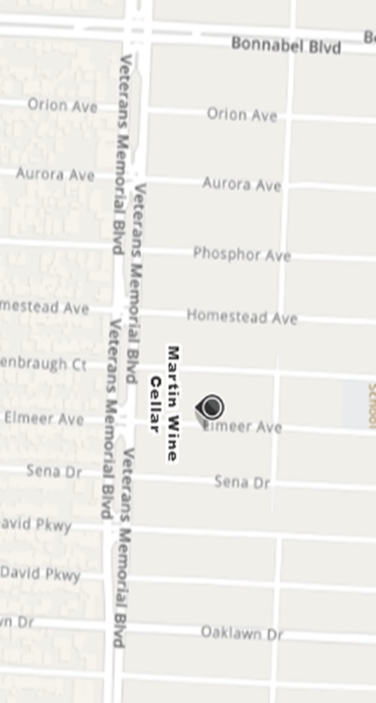

**Member Resources**

[Facebook](http://www.facebook.com/aorn) <http://http://www.facebook.com/AORN>

nav_logo

[www.ornurselink.org/Pages/home.aspx](http://www.ornurselink.org/Pages/home.aspx)

3M has upcoming webinars at which you can obtain free CEU`s.

<https://promo.3m.com/rc/3MMEDICAL/ipdeducationwebinarcalendar>

 [Twitter](http://twitter.com/aorn) <https://twitter.com/AORNofNewOrlean>

(You are seeing it correctly; there is no “s”)

**Chapter Webpage:** [www.aornofneworleanschapter1902.com](http://www.aornofneworleanschapter1902.com)

**Standard – 154**

**Lifetime – 24**

**2/3yr – 28**

**Retired –7**

**Leader-6**

**Associate – 4**

**Student Members – 1**

**Total Members – 229**

**Be sure your chapter membership status on “My AORN” states “Chapter 1902”.**

**Please bring an OR nurse with you to the chapter meetings. We our new members!**

**Membership Information**

## **Membership due to Lapse**

**Membership expires on the last day of your renewal month. Here is a reminder that your membership expiration is in the near future:**

**December**

Christina Childers

Hollie Davis

Layna Forbes

Eddie Graebert

Autumn Hamm

Lauren Karwoski

Kira Kish

Pamela Lazas

Samantha Margiotta

Jennifer Mills

Jennifer Pitre

Traci Termine

Leon Watkins

Leah Yancey

**November**

Julie Bernard

Marie Bond

Anissa Buras

Rochelle Cazaubon

Wendy Durocher

Alison Green

Denise Knight

Kelsey-Lynn Leabo

Caldwell Lewin

Devin Miles

Jasmine Loyd

Kerri MacDonald

R. McDonald

Brianna Marzett

Emilie Patterson

Jennifer Provenzano

Carrie Rooks

Darlene Russo

Amy Uddo

Brandie Ward

Sheila Yehl

**October**

Cathy Barreca Marilyn Porea-Sutton

Jamie Cambre Christy Simeon

Tondra Cheramie Kensey Thibodaux

Miranda Chiquet Christine Waller

Kerrie Clark Jasmine Warren

Nicole Cook

Garret De Ramos

Aimee Falgout

Rosa Flores-Castellon

Ramsey Hare

Mary Parker Haynie

Stephanie Heaphy

Michelle Heisser

Adrienne Holdridge

Nancy Ledet

Caroline McInnis

**Trea$urer’s Report:**

**Beginning balance:**  **$7,573.49**

**Deposits: $ 3228.00**

**Expenses:** **$ 96.79**

**Ending balance: $10,884.70**

**Respectfully submitted,**

**Bobbi Carew, BSN, RN**

**Treasurer**

**AORN Chapter 1902**

Deposits $3088.00 – Credits from AORN Conf

$140.00 – AORN oper Aug

$140.00 – AORN oper Sept



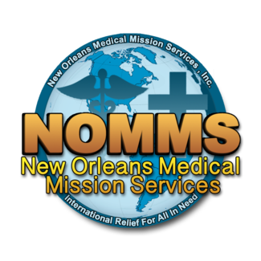

**NOMMS Medical Mission**

**May 21-28, 2022**

Ever wanted to go on a medical mission but didn’t know what to do or how to get involved? This is your opportunity to do something rewarding and put a deposit in your heart bank! Dr. Tom Kennedy is planning a mission to the Dominican Republic for May 21-28, 2022.  He is looking for nurses, surgical techs and physical therapists. They will be performing Pediatric Orthopedics, ENT and General Surgery to including thyroidectomies and GYN procedures. Cost is $800 all-inclusive and tax deductible. You will be staying at a beach resort where you can relax after working! If interested, please go to nomms.org and complete an application.

New Orleans Medical Mission Services, Inc.

P. O. Box 6249

New Orleans, LA 70174

Office: (504) 392-1934

Fax (504) 368-2011



**Committee**

**Corner**

**Community Service Committee Members**

Chair: \_\_\_\_\_\_\_\_\_\_\_\_\_\_\_\_\_\_\_\_\_\_

Roxanne McNally

Elaine Stock

Jennifer Foster

**Membership Committee Member**

Chair: \_\_\_\_\_\_\_\_\_\_\_\_\_\_\_\_

Roxanne McNally

Elaine Stock

Jennifer Foster

**Research Committee Members**

Chair: Michelle Delima

Mary Anne Toledano

**Social Committee Members**

Chair: Mary Anne Toledano

Roxanne McNally

Elaine Stock

**Fundraising Committee Members**

Chair: \_\_\_\_\_\_\_\_\_\_\_\_\_\_\_\_

Nora Lambert

**Chapter Hospital Liaisons** 

**Children's-Christi Guillot VA-Stephanie Wall**

**Lakeview-Christal Cook Touro-Cheryl Johnson**

**Ochsner Kenner-Shari Fourcade EJGH-Eddie Graebert**

**Ochsner Baptist-Lauren Levert Tulane-Linda Levesque**

**Ochsner Elmwood-Kathy Blanchard UMC-Elaine Stock**

**Crescent City-Melynda Nguyen Ochsner Jeff Hwy-Bobbi Carew**

We would like to encourage a member from

**Ochsner West Bank and West Jeff**

and **all other facilities** to volunteer as a liaison to assist with providing information to your peers. If you are interested, please email Bobbi Carew at [Roberta.Carew@ochsner.org](mailto:Roberta.Carew@ochsner.org)

Thanks to those members listed above who have volunteered - you are **greatly** appreciated!



*Happy*



‘[

***Do you shop on Amazon?***

**Did you know you can donate to the AORN Foundation**

**with every purchase?**



[Click here to find out more!](https://www.amazon.com/gp/help/customer/display.html/ref=sxts_snpl_3_2_cadfdfa1-9169-4a88-8997-3f369371b055?nodeId=201365360&pd_rd_w=Bsggn&pf_rd_p=cadfdfa1-9169-4a88-8997-3f369371b055&pf_rd_r=8MXDFQHC87M5ASD7EKGV&pd_rd_r=9b42b614-daa3-4dbb-9f7b-df176760f39b&pd_rd_wg=fZdHc&qid=1566354168)