[](http://www.bing.com/images/search?q=clip+art+new+orleans&view=detail&id=0D3880414582BD4E12DF0B39D1961788D275BAE3)

**PeriOperative Potpourri**

**New Orleans - Chapter 1902**

April 2016

# **President’s Message**

**2015 – 2016 Officers**

**President**

Amanda Martin-Sanchez, BSN, MEd, RN, CNOR [asanchez@ochsner.org](mailto:asanchez@ochsner.org)

**President-elect**

Sharon Guardina, BSN, RN, CNOR

[sguardina@att.net](mailto:sguardina@att.net)

**Vice President**

Linda Levesque, MSN, RN, CNOR [Linda.Levesque@ hcahealthcare.com](mailto:Linda.Levesque@%20hcahealthcare.com)

**Secretary**

Mary Anne Toledano, BS, BSN, RN

[mstoledano@ejgh.org](mailto:mstoledano@ejgh.org)

**Treasurer**

Sheila Ostrow, RN,CNOR, CRNFA

[ostrow711@aol.com](mailto:ostrow711@aol.com)

**Board of Directors:**

Beth Eustis, RN, CNOR

[clyzbeth@cox.net](file:///C:\Users\Mary%20Anne\Desktop\clyzbeth@cox.net)

Christal Cook, MSN, RN, CNOR

[cnorchristal@gmail.com](mailto:cnorchristal@gmail.com)

Sarah Hunsucker, RN

[seh3913@gmail.com](mailto:seh3913@gmail.com)

Nathalie Walker, MBA, RN, CNOR

[gw\_nat@bellsouth.net](mailto:gw_nat@bellsouth.net)

Ann Burghardt-Dieck, MSN, MHA, RN, CNOR annburg@msn.com

**Nominating & Leadership Development**

Carrie Simpson, BA, BSN, RN, CNOR

[carrie.simpson@lcmchealth.org](mailto:carrie.simpson@lcmchealth.org)

Frances Hughes,BS, RN, CNOR

[fmhugs@yahoo.com](mailto:fmhugs@yahoo.com)

Melissa Guidry, BSN, MPH, RN, CNOR, Chair [guidrymelissa@yahoo.com](mailto:guidrymelissa@yahoo.com)

**LA State Council Liaison**

Carrie Thomson, BSN, RN, CNOR

**Newsletter Editor**

Mary Anne Toledano, BS, BSN, RN [mstoledano@ejgh.org](mailto:mstoledano@ejgh.org)

**Assistant Editor**

Frances Hughes,BS, RN, CNOR

[fmhugs@yahoo.com](mailto:fmhugs@yahoo.com)

**Webmaster**

Ramie K. Miller, MSN-HCSM, RN, CNOR [ramiemiller@yahoo.com](mailto:ramiemiller@yahoo.com)

favorites was a stuffed "squame"! I realize that might not excite you, but to someone who teaches scrubbing, gowning, and gloving as much as I do, the "squame" was a coup!

Speaking about the business of the organization, May brings us to the election of chapter officers to guide us into 2017. If you have even an inkling of interest, please throw your hat into the ring and run for office. The chapter needs you to become involved in the leadership roles to bring your ideas forward and and meet the needs of the membership. If you have ever heard yourself say, "I don't know why they . . . (You fill in this part)," it's time for you to have your voice heard.

There are experienced chapter leaders willing to help you grow into these roles and learn the ins and outs of each office. You will have the benefit of a President (Sharon Guardina) who has held multiple chapter offices through her association with AORN. NOW IS THE TIME TO SUBMIT A WILLINGNESS TO SERVE FORM! Don't wait . . . Embrace the Nike philosophy and JUST DO IT!

Respectfully submitted,

Mandy Martin-Sanchez, BSN, Med, RN, CNOR



It's FINALLY time for the AORN Surgical Conference and Expo! This is our opportunity to learn in so many different forums . . . Educational presentations by the conference speakers, sessions on the Expo floor, self-study guides from our industry partners, individual learning opportunities with our industry partners about their products or services, and the networking with other perioperative nurses from around the world! Then, more opportunity to learn about the business of AORN, Inc. at the business meetings during the conference. Unfortunately, most of you are not able to attend this year in Anaheim. So . . . we will bring the best of what we learn to you at our chapter meeting next month! We will try to have lots of pictures for you to help you "experience" a bit of the excitement that is inherent with this event.

The chapter delegates, Melissa Guidry, Sharon Guardina, Ramie Miller, Angela Young, Ann Burghardt-Deich, Carrie Simpson Thomson and yours truly, will be sharing our experiences from the conference to bring you the best of what we learned and/or found. Angela will report from a first-time attendee perspective; the rest of us will focus on educational, social, networking and organization business topics. If you are attending Expo, please join us at the April meeting and share the best of what you experienced. Hopefully, there will

be enough room in our suitcases to bring back a few goodies from the vendors! Last year one of my



##### 

**Legislative Report by Nathalie Walker, MBA, RN, CNOR**

**Chapter**

##### **1902**

##### **Calendar**



**April 27th - Tulane**

**May 25th - TBA**

**June 22nd - Installation Banquet**

******

***Meetings***

***start at***

***4:30 PM***

***unless***

***otherwise***

***noted***

Martha Stratton announced during the January 20 Town Hall, AORN is offering new ways to volunteer for committees and task forces.  Instead of simply submitting willingness to serve forms, members will learn of specific volunteer opportunities and be able to apply more directly to those committees, task forces, and other projects that are of interest to the member.  Specific committee, task force and project announcements will be published in PeriOp Insider throughout the year.

As part of this process improvement for AORN’s volunteer structures, it was decided to open up AORN’s legislative and policy work to all AORN members with an interest in health policy and legislative affairs.  After Expo in Anaheim, the National Legislative Committee will no longer be an appointed AORN committee.  We will rename the group the **National Legislative Forum.**

**The National Legislative Forum** will be more of a membership assembly convened by AORN Government Affairs staff to coordinate and support AORN’s health policy initiatives.  It will be **open to all AORN members** with an interest in health policy and legislative affairs.  Amy Hader and Danielle Glover will continue to work directly with Forum members on strengthening state level relationships, advocating for AORN’s legislative priorities at the state and federal levels, implementing the IOM Future of Nursing recommendations, and increasing member engagement in Time Out Day, Perioperative Nurse Week, and state nurses association legislative days. They will also continue to provide advocacy training and resources to Forum members, including opportunities to attend ANA’s Advocacy Institute and the Nursing Alliance Organizations’ Nurse in Washington Internship program.

It is the hope that by expanding the group, we will increase membership and participation in our monthly calls.  We will continue to rely on you for guidance, ideas, and encouragement. We hope that you will continue to lead in the legislative arena by encouraging other AORN members to become involved with policy making and with AORN Government Affairs.

Anyone interested in participating should send an email to [dglover@aorn.org](mailto:dglover@aorn.org) to request to be placed on the email list to receive future information. The legislative education session and legislative reception are confirmed and ready. We have buttons and flash drives for the AORN Government Affairs booth at Expo. Hope to see you there.

**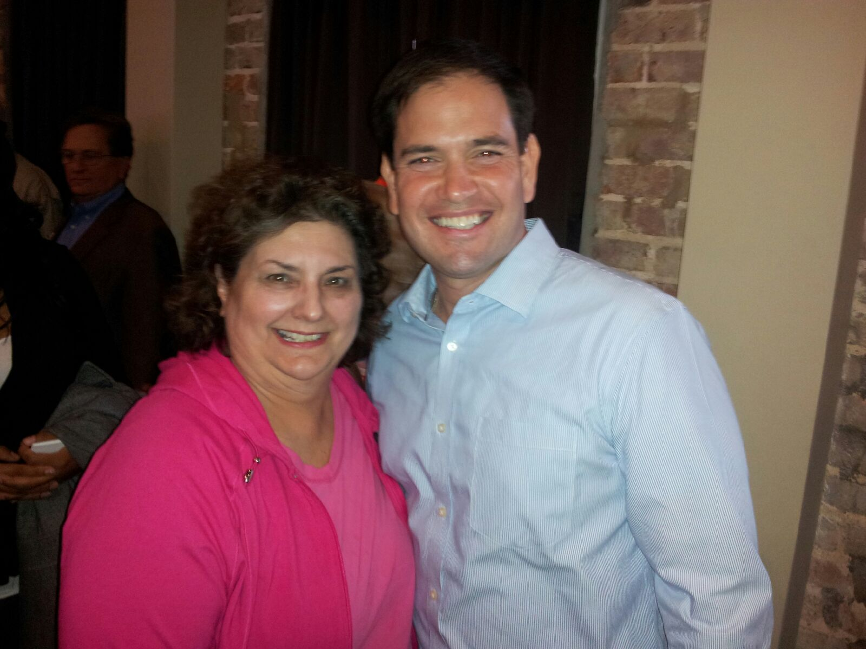**

**Respectfully Submitted by,**

**Nathalie Walker MBA, RN, CNOR**

**AORN of New Orleans BOD**

**Chapter Bylaws and Policy Committee Chair**

****

**Meeting Minutes - from the secretary:**

on themselves. The wave motion is like the motion of an inchworm. There’s no constant pressure applied. It should never hurt. It is important to drink a lot of water after a reflexology session to flush out the toxins and stress.

Vivian is currently studying aromatherapy, which works together with reflexology. She defined aromatherapy, aka essential oil therapy, as the art and science of utilizing naturally extracted aromatic essences from plants to balance, harmonize and promote the health of body mind and spirit.

She defined essential oils as a volatile substance derived from a plant that contains the natural smell and characteristic of that plant. They are highly concentrated and more powerful than dried herbs. They can be used topically and aromatically in cooking, cleaning, massage, etc.

This practice is also not new. Egyptians, Chinese, Romans and Greeks have used it for thousands of years. There are over 600 references to essential oils in the Bible. Frankincense and myrrh are two commonly mentioned oils in the Bible. The Egyptians used essential oils to promote health and to prepare a body for burial.

Over time, essential oils have been researched and applied in many situations to benefit all. New benefits

**Continued on page 9**

Mandy Martin-Sanchez called the March chapter meeting to order at 4:35 PM at Ochsner Kenner. Mandy welcomed attendees and introduced Vivian Stillwell, a certified OR nurse as well as a certified, registered reflexologist (CRR). Vivian presented a one hour continuing education program on “Reflexology and Aromatherapy.” The contact hour documents will be emailed to attendees after completing the online evaluation in the three-week timeframe allowed.

Vivian defined reflexology as the science that deals with the principal that there are reflex areas in the hands and feet that correspond to all the organs, glands and all the parts of our bodies. It is a unique method of using the thumb to relieve stress and tension in the body by increasing blood flow, releasing nerve endings and restores homeostasis in the body.

Reflexology is not a new practice; the ancient Egyptians used it thousands of years ago. In tombs of Egyptians there are murals depicting reflexology being performed on the king.

Eunice Ingham is thought of as the mother of reflexology in the US. She introduced the practice to the U.S. from Europe. It’s based on a form of zone therapy that is the basis for reflexology today. Many methods are out there, but her’s is the original. In her book there are hand and foot charts to show the zones of reflexes in the body.

Vivian had the attendees practice some techniques

**Congratulations to EJGH**

**Surgery Department**

**for receiving the CCI designation**

****



**Please remember to renew!**

**Total Members – 197**

**Standard - 113**

**Lifetime – 7**

**2/3yr - 19**

**Retired – 11**

**Associate – 5**

**Student Members – 43**

**Group Mbr Level 4 - 1**

**When you renew, please check your membership card to see that it states “Chapter 1902”. If your name is then not on our Roster and our Chapter does not receive the chapter dues you pay.**

[Facebook](http://www.facebook.com/aorn) <http://http://www.facebook.com/AORN>

nav_logo

[www.ornurselink.org/Pages/home.aspx](http://www.ornurselink.org/Pages/home.aspx)

3M has upcoming webinars at which you can obtain free CEU`s.

<https://promo.3m.com/rc/3MMEDICAL/ipdeducationwebinarcalendar>

 [Twitter](http://twitter.com/aorn) <https://twitter.com/AORNofNewOrlean>

(You are seeing it correctly; there is no “s”)

**Chapter Webpage:**

[www.aornofneworleanschapter1902.com](http://www.aornofneworleanschapter1902.com)





## **Membership News**

## **Membership due to Lapse**

**Membership expires on the last day of your renewal month. Here is a reminder that your membership expiration is in the near future:**

**East Jefferson General Hospital:**

With the certification of ten OR nurses in the past year, the EJ surgery department has achieved the CCI designation of **CNOR Strong**. Congratulations EJ!

**If you have news from your facility**

**Please send any updates to**

**Mary Anne Toledano**

**at mstoledano@ejgh.org**

**April**

Shirley Broussard

Jarrod Cashe

Caroline Conway

Mary Jo D’Amico

Katie Faciane

Tracey Galassi

Mary Kay Harvey

Anita Jackson

Amy Langlinais

Susan McPherson

Ann Moll

Wanita Montreuil

Donna Moore

John Ostermann

**May**

Keeonna Baptiste

Brett Connolly

Stephanie Danielson

Judy Dufrechou

Sharon Guardina

Rebecca Harris

Sherry Harvey

Lisa Hoffman

Mary Morvant

Tracy Narcisse

Sally Pirfo

Jared Vappie

***Community Outreach Project:***

Please bring non-perishable items, hotel shampoos, etc. to next meeting for the homeless shelter at St. Joseph’s Catholic Church on Tulane Avenue. Sharon Guardina will drop them off to the shelter.

• Small bottles of shampoo •Eye glasses

•Non-perishable foods items •Socks

***Thank you!!!***

**Need Volunteer Hours for Career Ladder?**

The New Orleans Medical Mission needs volunteers. They meet at 625 Distributors Row on Wednesday and Saturday mornings from 9 am 1 pm. They pack inventory to get it ready for shipping to locations in need. If you need volunteer hours they would love your help. They also go on medical missions. They are collecting school uniforms and sports uniforms for Honduras. If anyone is interested in volunteering or have donations please contact Mary Morvant at [**Robotqueen311@hotmail.com**](mailto:Robotqueen311@hotmail.com)**.**

**Looking for a few good members with**

**new ideas to run for office 2016-2017....**



Our chapter is establishing a ballot of officers for this next year. We are looking to fill President-Elect, Vice-President, Secretary, Board of Directors x2 and Nominating Committee X2. In the past, the President-Elect candidate has attended the Leadership Academy scheduled for May in Denver. We are encouraging members to get involved and consider volunteering to fill one of these open positions. The willingness-to-serve form is located in this newsletter.

If interested, please email me at guidrymelissa@yahoo.com or call me at 504-442-9747.

Respectfully,

Melissa Guidry

Nominating Committee Chair

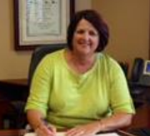

https://www.aorn.org/WorkArea/images/application/spacer.gif

** Congratulations to**

## **the new AORN Election Winners**

### \*President-Elect - Nathalie F. Walker, MBA, RN, CNOR

### Vice-President - Missi F. Merlino, MBA, RN, CNOR

### Secretary- Holly S. Ervine, MSN, RN, CNOR

### Board of Directors:

Elizabeth S. Pincus, MSN, MBA, RN, ACNS-BC, CNS-CP, CNOR

**\*Carrie Simpson, BSN, RN, CNOR**

Dawn Myers Yost, MSN, RDH, RN, CNOR, CSSM

### Nominating and Leadership Development Committee:

Brandy Miller, MHA, MSN, RN, CNOR

Cheryl Langford, MSN, RN, CNOR

Ruben Barrios, MSN Ed, BSN, RN, CNOR

**\*Chapter 1902 Members**

1. Log onto the AORN website and click on “My AORN”
2. Under “My Account”, click on “Update Profile”
3. Update “User Profile” with current email address, employer, etc.

Have you updated your ***personal profile*** on the AORN website?



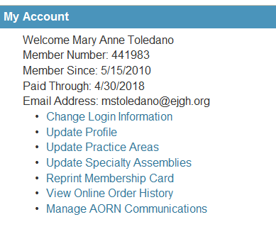



Connie Garrett FL

Tee G. Goyer VA

Cheryl Langford MN

Brandy Miller IN

Ramie Miller  LA



newsletter and on the chapter website. No one had any corrections so the minutes were approved as published.

Financial Statement: Sheila Ostrow, Treasurer, reported that the account balance is $11, 866.68. Sharon Guardina reported that the chapter made a total profit of $1531.47 on the annual seminar. The chapter made $400 from vendors, $272 from the silent auction, $33 from the 50/50, $995 from attendees; minus expenses of $161.93 for refreshments and a PayPal fee of $6.60. Mandy thanked everyone for helping put the seminar together.

Legislative: Next year’s AORN president, Martha Stratton, has decided to change the legislative committee. Instead of a national legislative committee, there will be an advocacy and legislative forum to include all of the members. There will be a monthly conference call in which everyone can participate.

Newsletter: Mary Anne Toledano asked that all inform- ation for the newsletter be in by the end of the month.

Ways and Means: Sharon Guardina reported that the seminar went very well, despite changing the date, changing speakers and loosing vendors.

Nominating Committee: Melissa Guidry reported that the chapter will be holding elections soon for 2016-2017 year. The following offices will be open: president elect, vice president, secretary, board of directors x 3 and the nominating committee x 2. If anyone is interested or has someone to nominate please contact Melissa, or talk to Mandy or Nathalie for more information on the open positions. Interested members should fill out the willingness to serve form (in back of the newsletter) and turn it in to Melissa.

Expo News:

Voting for National Officers: Voting for candidates is open. Please cast your vote for your choice of officers for the next year! Voting for the AORN National Candidates is open to all members in good standing through Tuesday, April 5th at 11:59PM. Candidates’ bios and election statements are on the AORN website. Each candidate answered four questions and the answers are on the site.

Old Business: No old business.

New Business: The 2016 AORN Volunteer Leadership Academy is an opportunity for Chapter, Specialty

are always being discovered. The extraction of essential oils has also been perfected over the years. There are four main methods:

1. Steam Distillation
2. Cold Pressing
3. Resin Tapping
4. Absolute Extraction

Essential oils can be used aromatically, such as using a diffuser or just smelling it from a bottle. Oils can be used topically in massage oils, lotions, roll on bottles or straight on the skin. But research it first. Oils are very concentrated. Essential oils can also be used in our diet, but make sure they are edible first. Some can be toxic if not used correctly.

Please do your research before using essential oils. Some oils are considered “hot” and must be diluted to be used topically. Also, not all are meant for consumption. Vivian recommended getting a book to help with essential oil usage.

Essential oils work on the limbic system. Some smells remind you of a memory from your past. There are receptors in your nose and on the roof of your mouth. Inhaling the fragrance stimulates these receptors.

AORN changed their recommendation last year for complimentary care. There are seven new standards that recommend usage of complimentary techniques in caring for our surgical patients. Today there are other options for nurse’s to use with patients. For example, lavender oil could be used to relieve stress in the surgical patient. Simply putting some oil on a cotton ball for the patient to sniff could help them calm down before surgery. Also peppermint and ginger are excellent for helping with stomach upset.

Vivian had a drawing for door prizes after her presentation. The winners were: Melissa Guidry, Tammy Sill, Carrie Simpson, Nathalie Walker, Renauda Jefferson, Sharon Guardina and Sarah Hunsucker. Elaine Stock won the 50/50 raffle.

Mandy thanked Vivian for her presentation and started the business portion of the meeting.

Approval of the Minutes: The minutes from the February meeting were published in the March



**Meeting Minutes – continued from page 3**



**Meeting Minutes – continued from page 9**

Sharon Guardina reported that she is looking at having the installation banquet at Porter and Luke’s on Metairie Road for $25. More information to follow.

Carrie Simspon reminded everyone that there will be a Neuro, Ortho, Trauma seminar in May at UMC. Please see the flyer for more information.

The Louisiana State Council is looking for a few volunteers to serve on the council. Please contact Carrie Simpson for more information.

Mandy asked if anyone had any new business. No one had anything, and the meeting was adjourned at 6:15 PM.

Assembly, and State Council volunteer leaders to join peers, colleagues, and AORN's Board of Directors to learn from experts on how to achieve and maintain success in your leadership role. This 2-day event includes workshops and small group discussions, networking, insights and education, plus lots of fun and camaraderie. The dates are May 20 – 21, 2016 and it’s at AORN Headquarters in Denver.

Certification grant funding is available for individuals and organizations for certification exams and study material. There are 11 individual grants and three organizational grants. The [application](http://www.informz.net/z/cjUucD9taT0yMDMyNjU3JnA9MSZ1PTkxMDkxNzI0JmxpPTEwNDc1MTIz/index.html) will be open until April 15, 2016.

The next meeting will be at Tulane and the Expo will be the topic of discussion. Also, Angela Young, a chapter delegate, will present on her Expo experience.



AORN CHAPTER 1902 PRESENTS

"SURGICAL EXPO 2016/AORN BUSINESS MEETING"

Please join us for our monthly meeting and Surgical Expo Presentations/Delegate Reports

WHEN: Wednesday, April 27th, 2016

WHERE: Tulane Medical Center – Reily Pavillion 1st Floor

TIME: 4:30PM

**\*\*\*AORN’s** Surgical Conference & Expo was in Anaheim, California on April 2-6, 2016. Come learn about the hot topics, latest technology and trends from around the world.

\*\*\*Parking - Saratoga Garage/enter the hospital from the 2nd floor catwalk

